
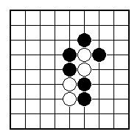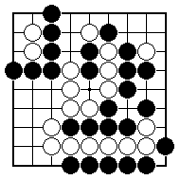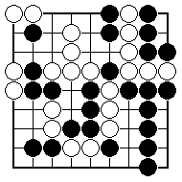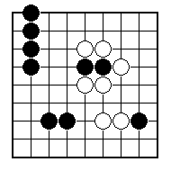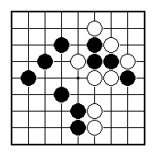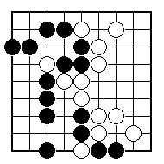
Black to play and take off two white stones.

Black to play and take off some white stones.

Black to play and take off some white stones.

Black to play and rescue the stones in atari.

Black to play and rescue the stones in atari.

Black to play and rescue the stones in atari.

NAME:
BRITISH GO ASSOCIATION CERTIFICATE LEVEL 1 - SHEET 3

CAPTURING GROUPS OF STONES

